**HUrricane**

**Design Document**

1. **Updated ER Diagram**

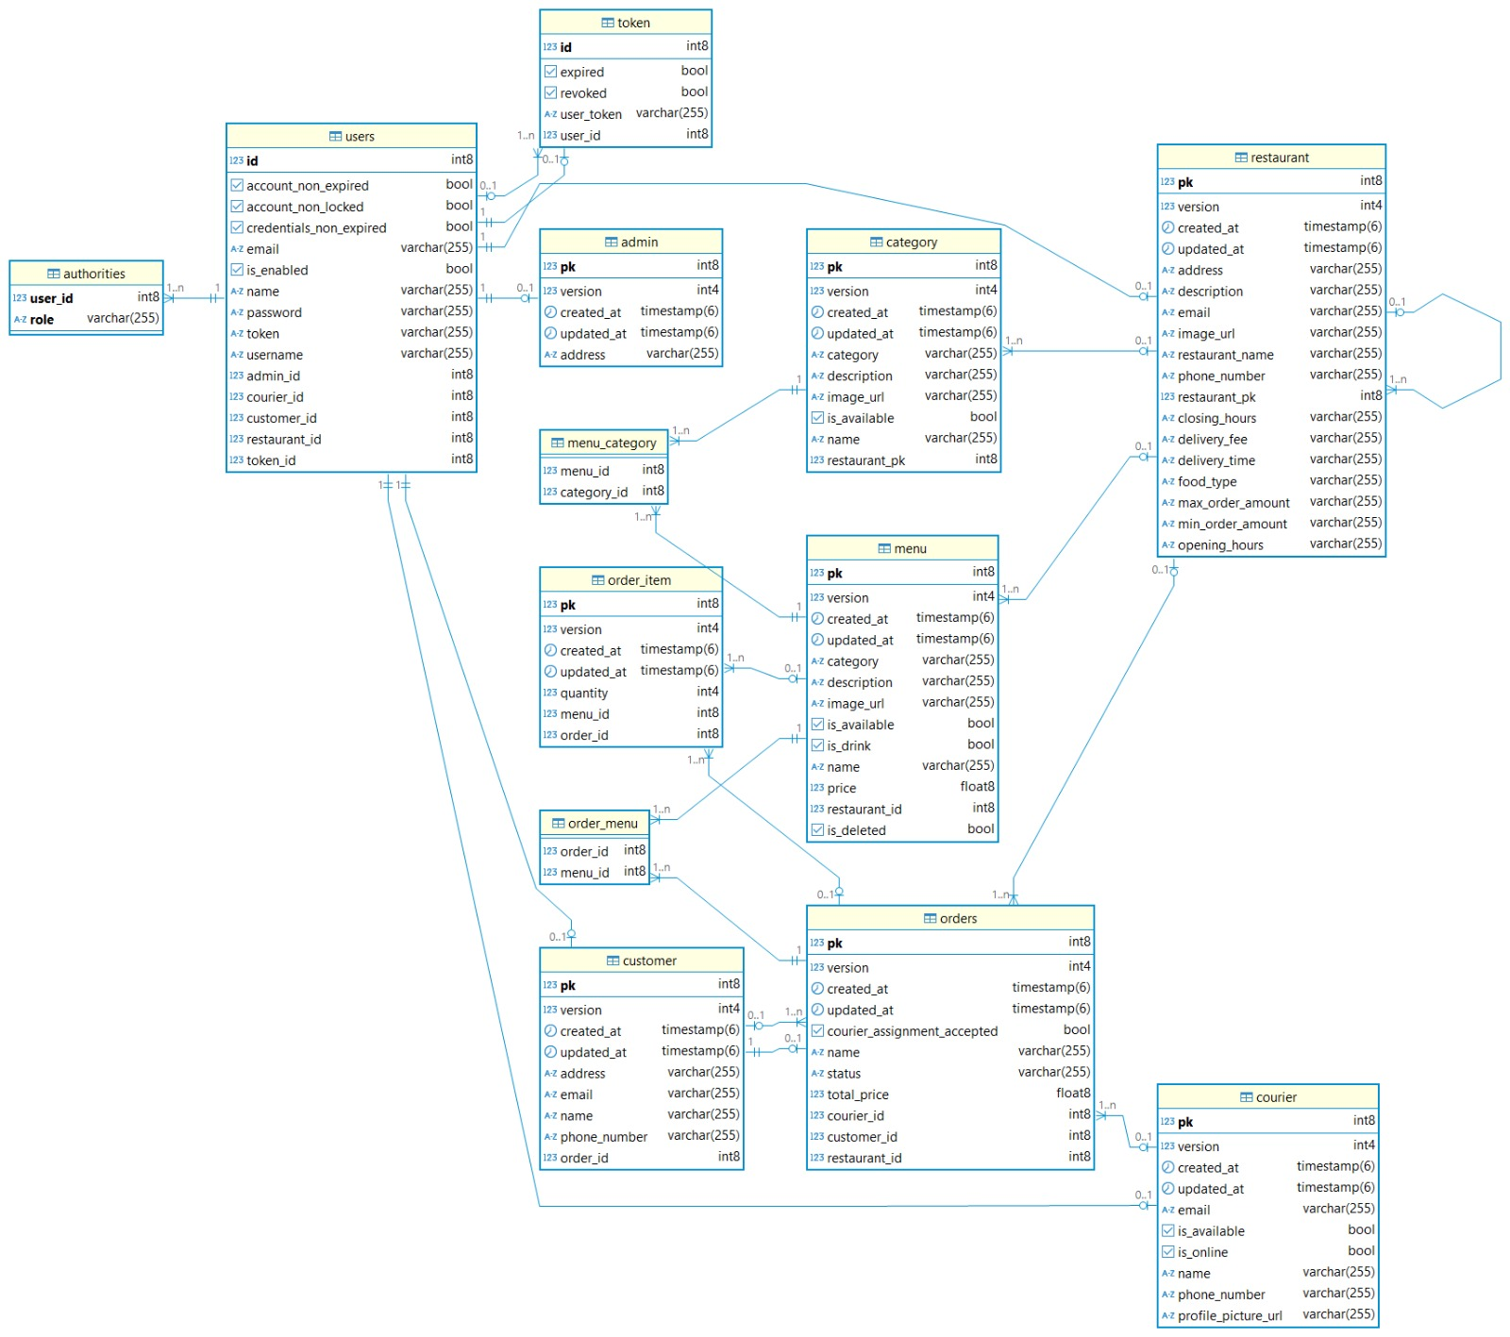

1. **Updated Class Diagram**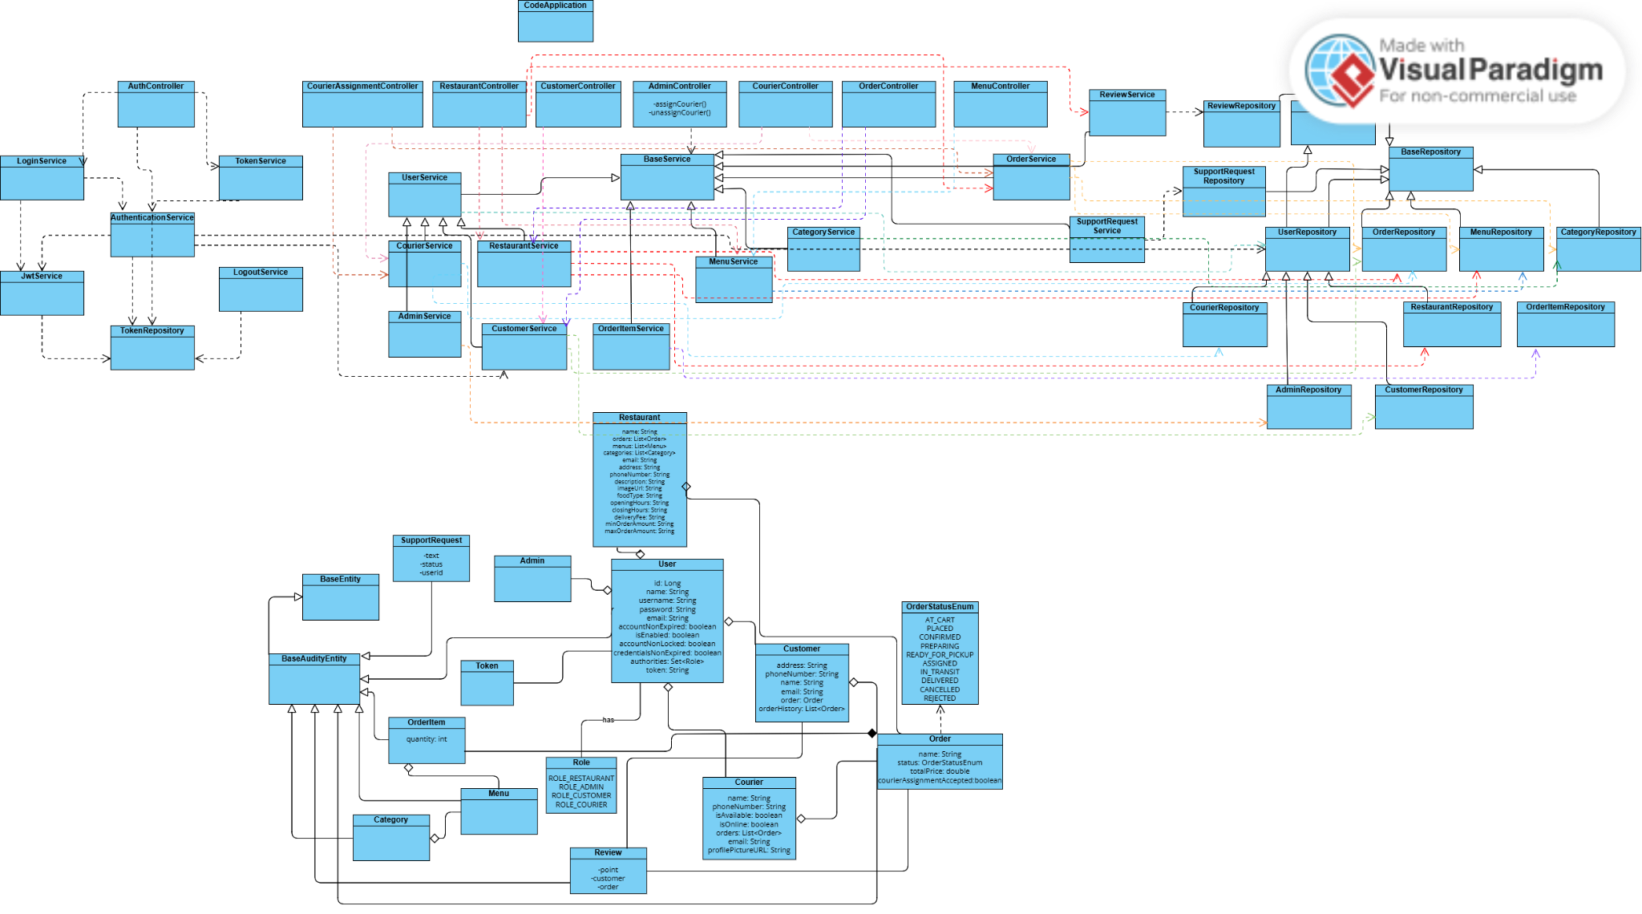
2. **Statechart Diagram**

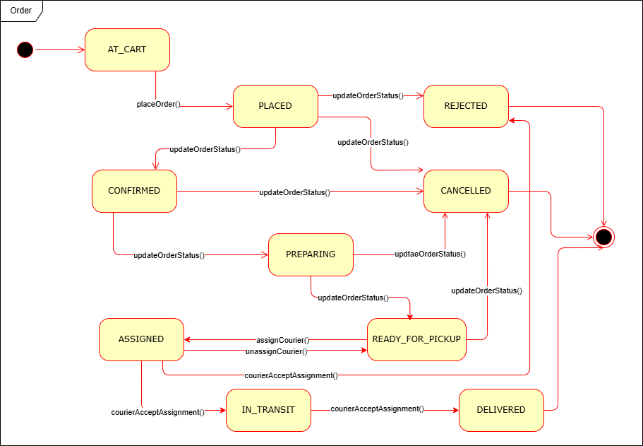

1. **Sequence Diagram1 (View Orders-Restaurant)**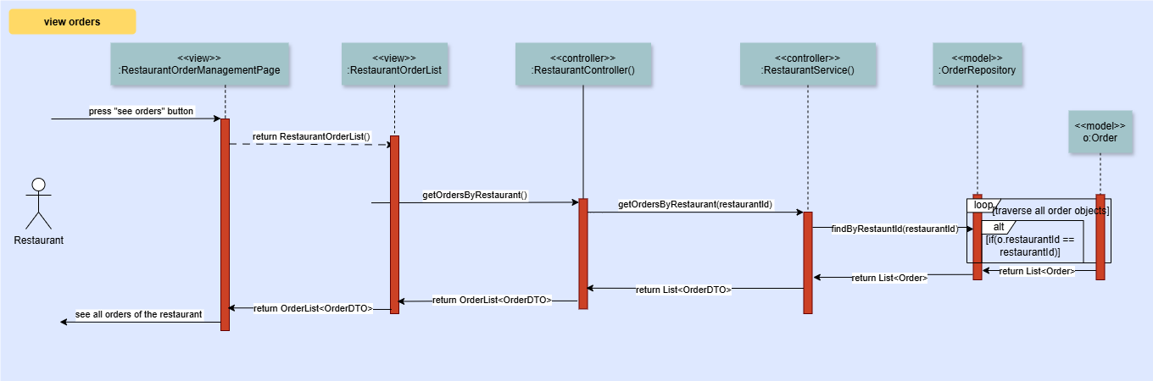
2. **Sequence Diagram2 (Assign Courier-Restaurant)**

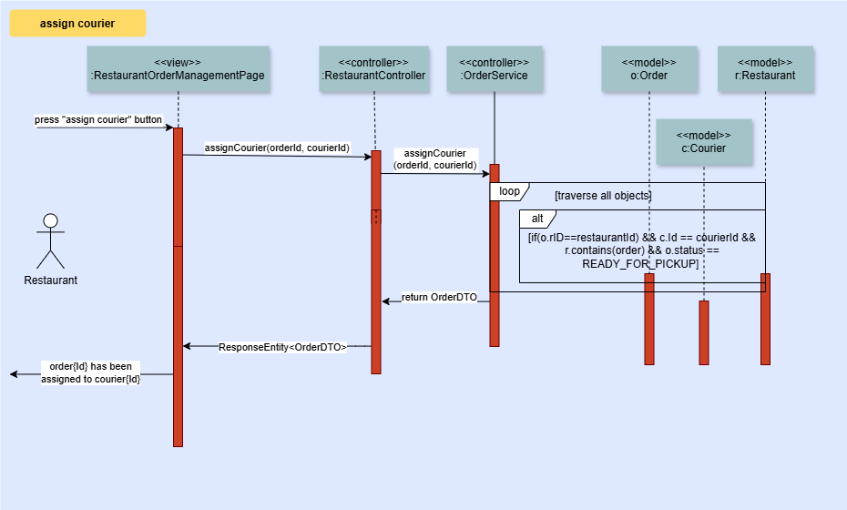

1. **Sequence Diagram3 (Search Restaurants-Customer)**

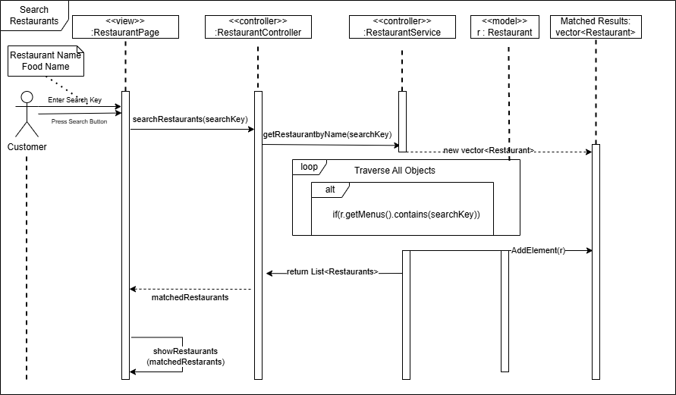

1. **Sequence Diagram4 (Search Restaurants-Customer)**

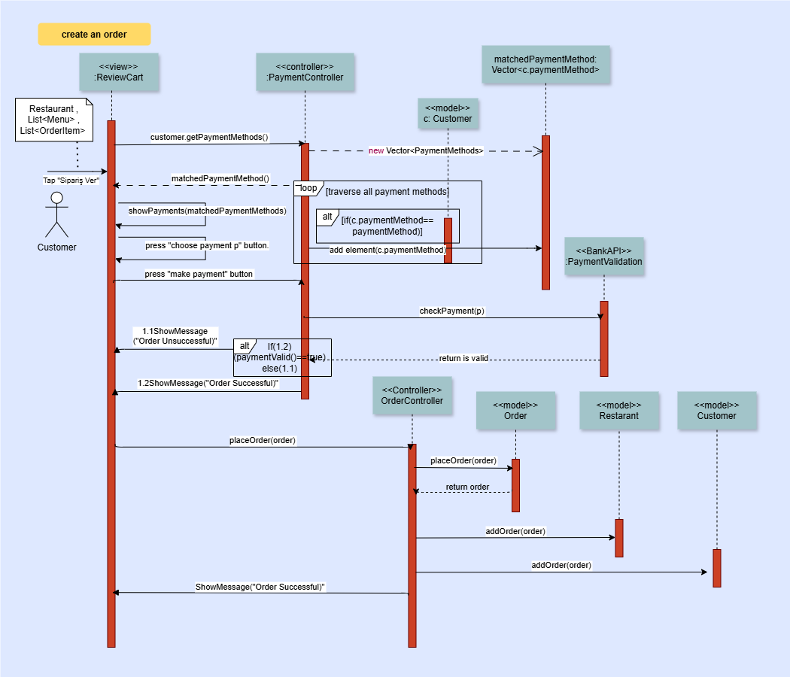

1. **Sequence Diagram5 (Accept Order -Courier)**

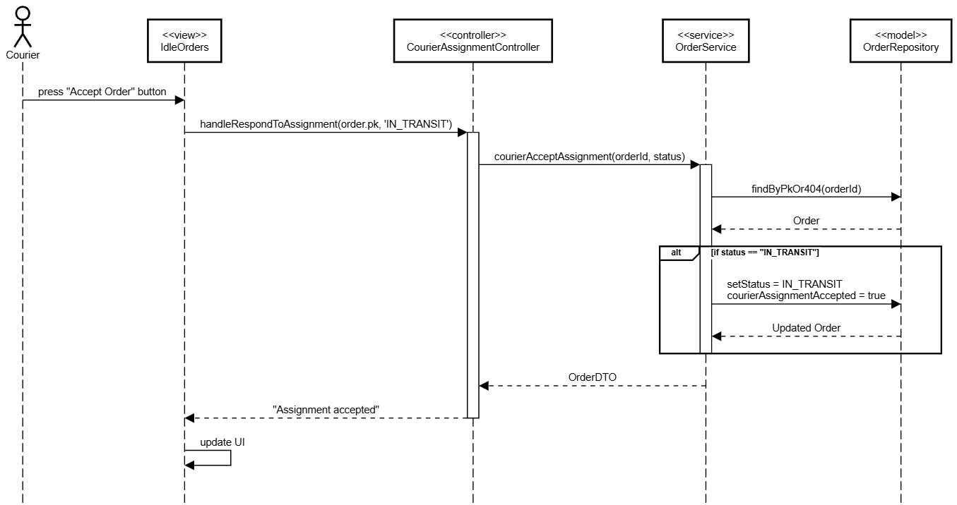

1. **Sequence Diagram6 (Remove Item from Cart from Review Cart-Customer)**

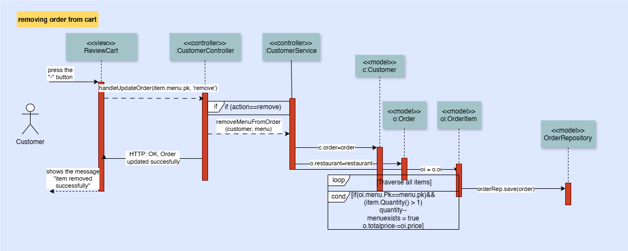

1. **Sequence Diagram7 (Add Item to Cart from Restaurant Page-Customer)**

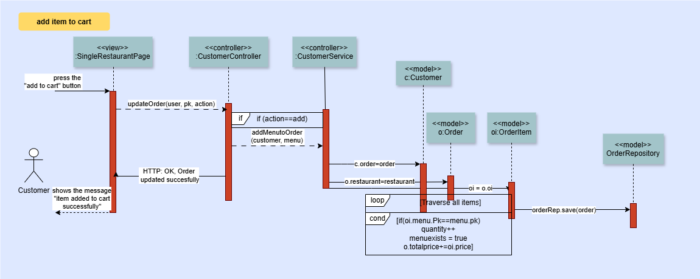

1. **Sequence Diagram8 (Reject Order-Restaurant)**

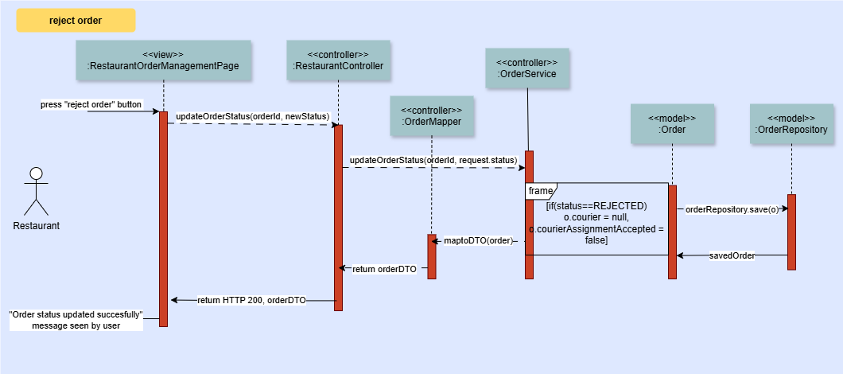

1. **Sequence Diagram9 (Add Food to Menu-Restaurant)**

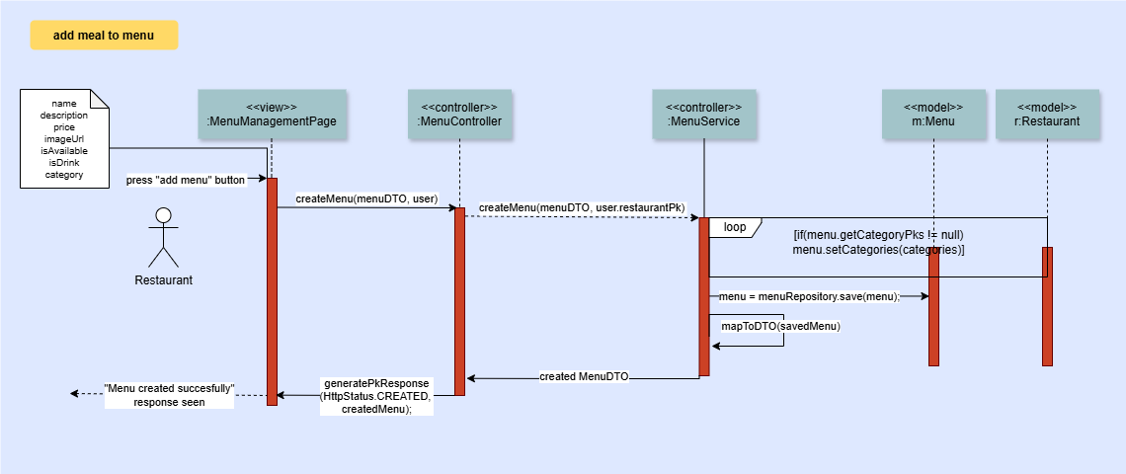

1. **References**

ChatGPT: <https://chatgpt.com/share/6817a2a7-40d4-800f-a3a5-1d162d98b5d9>